Ines Cerdan – Maxence Meissirel-Marquot

Abstract

The following database proposal aims to allow BPD to quickly see and identify all related case information regarding the criminal or any other party as well as the evidence and the judgement.

Database Proposal

Boston Police Department

On January 21st, we have been contacted by Boston Police Department to propose a new database system. During our meeting, our client came up with the following need:

“We are looking for a database to share between our offices that regroup all the information regarding all the criminals. We struggle to find related crimes and criminals. We also often confuse if they have been convicted or not and what are the attribute penalties per judgement. Also, It is important for us to identify who is in prison and where. Often, we send criminals to prison that are close to be full. Because we are working with administration, we sometimes have no idea which case is open or not, who are the people in charge, what are the penalties and if the crime has been resolve or not. For public safety we also need to identify which crime is related to which case as it allows us to faster identify if there are any relationship between the cases. Finally, we need to be able to quickly identify who are the witnesses so we can either ask more question or protect them. “

Accordingly, we came up with the following proposed reports:

1. List of all the criminals, the number of crimes they are suspects and the number of crime they have been judge guilty.
2. List of people currently in prison and there related penalty ending date
3. List of people who have an ongoing penalty.
4. List of Judgement type, penalty received, and the type of crime committed.
5. List of prison with criminals, count of prisoners, maximum capacity, their occupancy rate and average age of prisoners
6. List of case with “Unknown” Criminal cases, including the related crime details and evidences
7. Number of committed crimes per cases
8. Cases currently open and the number of related crimes and criminals
9. List of Cases including their name and the related witness
10. Cases list with administrative information judge and officer name, instance, opening , closing case date and duration

And the following procedures:

1. Person details and number of crimes for a specific person (output)
2. The level of offense of a crime (output)
3. The criminal record of a person

Based on the conversation with our client we identified the following information.

* A case has a name, an officer in charge, an opening and closing dated and it might have more than 1 crime related to it.
* Each crime has a type, a date, a victim, a criminal and one or more judgement.
* Each evidence has a type, collected date, description and it is related to a case
* A judgement also has a designated judge, decision and also a type and a date
* Depending on the decision, more than one penalty might be assigned; Example: prison + fine.

Some of the constraint that our client mentioned were:

* A need to avoid duplicated information about people details.
* It is important to allow all the crimes to appear when searching for a specific case.
* A register needs to be created for Criminal/Victim and Witness

# Database Structure

Considering the above-mentioned needs and limits, we came up with the following Data Structure:

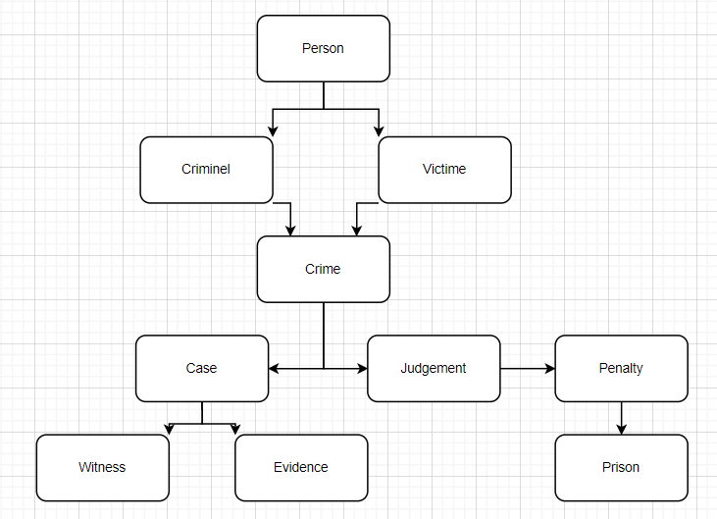

# Entity-Relational (ER) Model

According to our Data Structure and the data flow, we came up with the following ER Model.

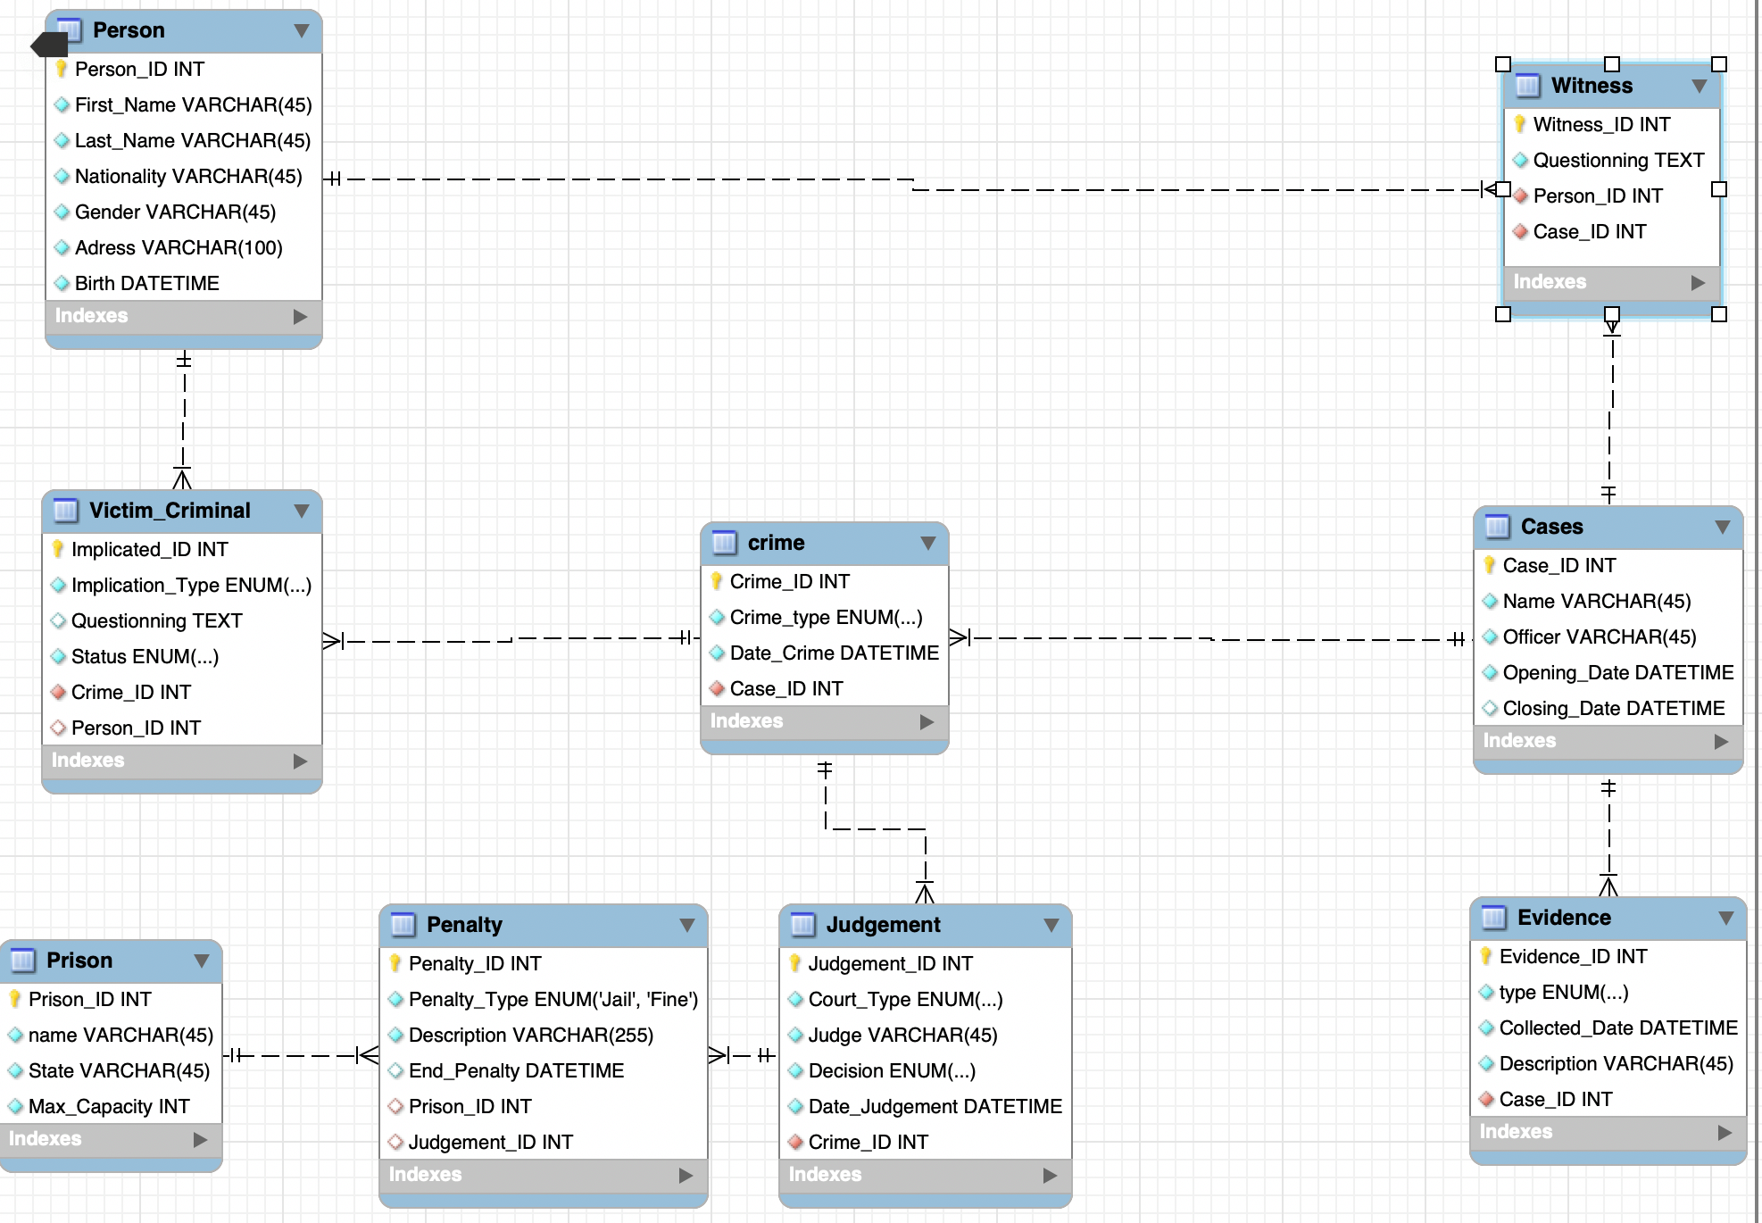

# Reports

Based on the developed ER, we created the following reports:

## List of all the criminals, the number of crimes they are suspects and the number of crime they have been judge guilty.

Code:

Select

P.person_ID,

P.first_name 'First Name',

P.last_name 'Last Name',

count(VC.implicated_ID) 'Suspected Nbr Committed crime',

count(PEN.Penalty_ID) 'comited crim'

from person P

left join victim_criminal VC on P.person_id=VC.person_id

left join Crime CR on CR.Crime_ID=VC.Crime_ID

left join Judgement JU on JU.Crime_ID = CR.Crime_ID

left join Penalty PEN on PEN.Judgement_ID = JU.Judgement_ID

where VC.Implication_Type="Criminal"

and Ju.Date= (select max(date)

from Judgement Jud

where jud.crime_ID=Ju.Crime_ID)

Group by P.person_ID;

Results:

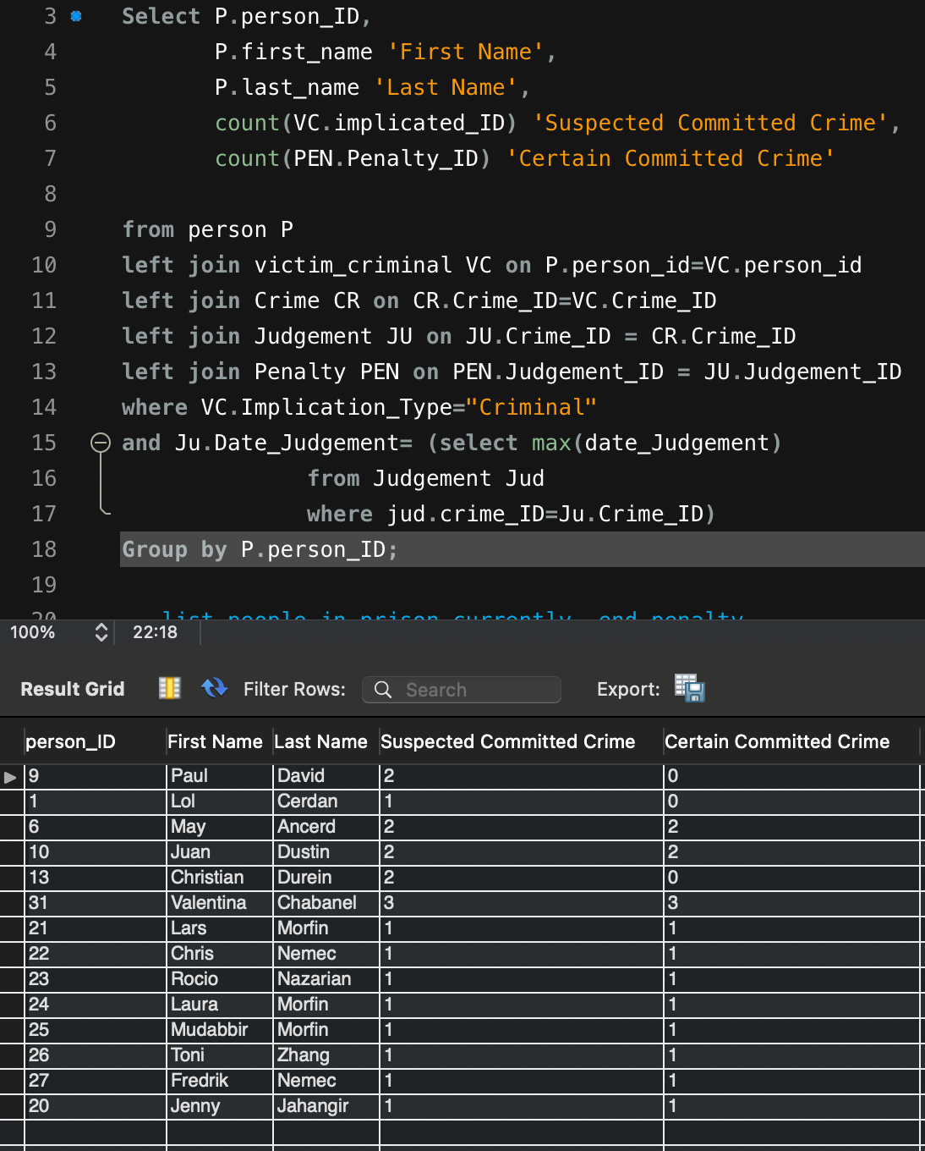

## List of people currently in prison and there related penalty ending date

Code:

Select

distinct(P.person_ID),

P.first_name 'First Name',

P.last_name 'Last Name',

PR.name 'Prison Name',

End_Penalty

from person P , victim_criminal VC, Crime CR, Prison PR, Penalty PE, Judgement JU

Where P.person_id=VC.person_id

and VC.Implication_Type="Criminal"

and CR.Crime_ID=VC.Crime_ID

and JU.Crime_ID=CR.Crime_ID

and PE.Judgement_ID=JU.Judgement_ID

and PR.Prison_ID= PE.Prison_ID

and Ju.Date= (select max(date) ## Subquery to get only poeple currently

from Judgement Jud

where jud.crime_ID=Ju.Crime_ID) ;

Results

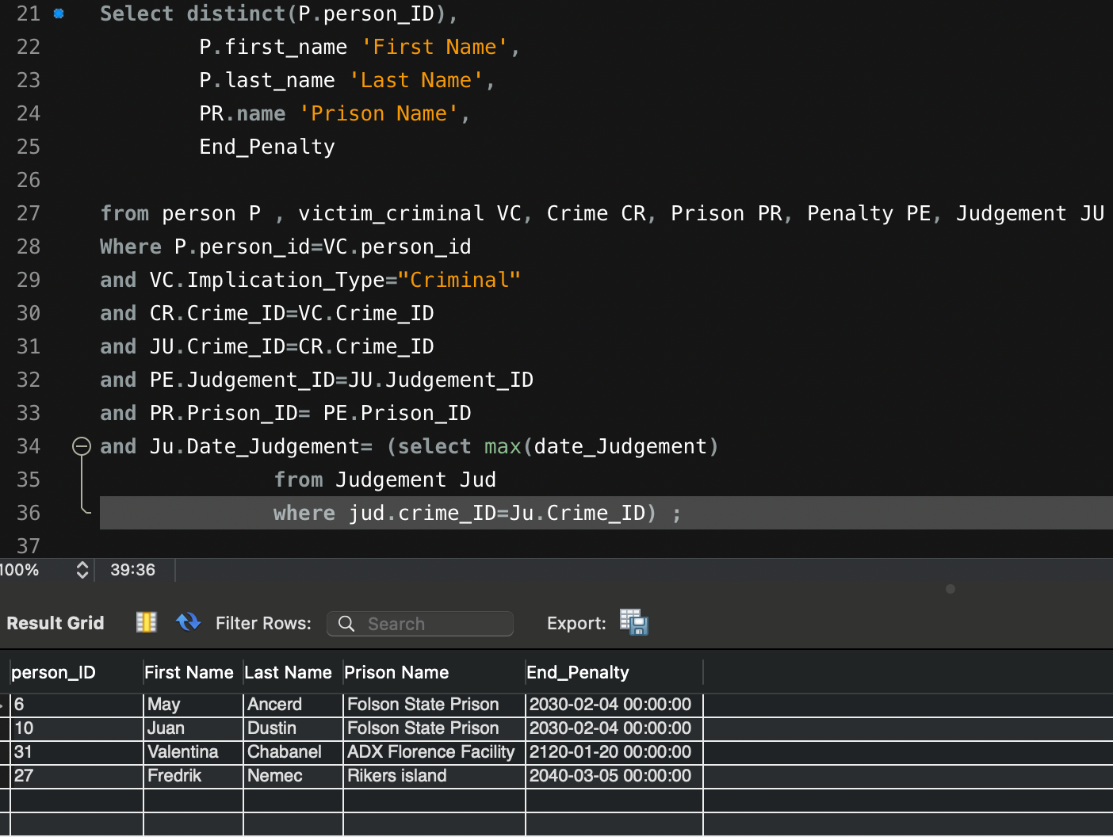

## List of people who have an ongoing penalty.

Code:

Select

distinct(P.person_ID),

P.first_name 'First Name',

P.last_name 'Last Name',

PR.name 'Prison Name',

End_Penalty

from person P , victim_criminal VC, Crime CR, Prison PR, Penalty PE, Judgement JU

Where P.person_id=VC.person_id

and VC.Implication_Type="Criminal"

and CR.Crime_ID=VC.Crime_ID

and JU.Crime_ID=CR.Crime_ID

and PE.Judgement_ID=JU.Judgement_ID

and PR.Prison_ID= PE.Prison_ID

and Ju.Date= (select max(date) ## Subquery to get only poeple currently

from Judgement Jud

where jud.crime_ID=Ju.Crime_ID) ;

Results:

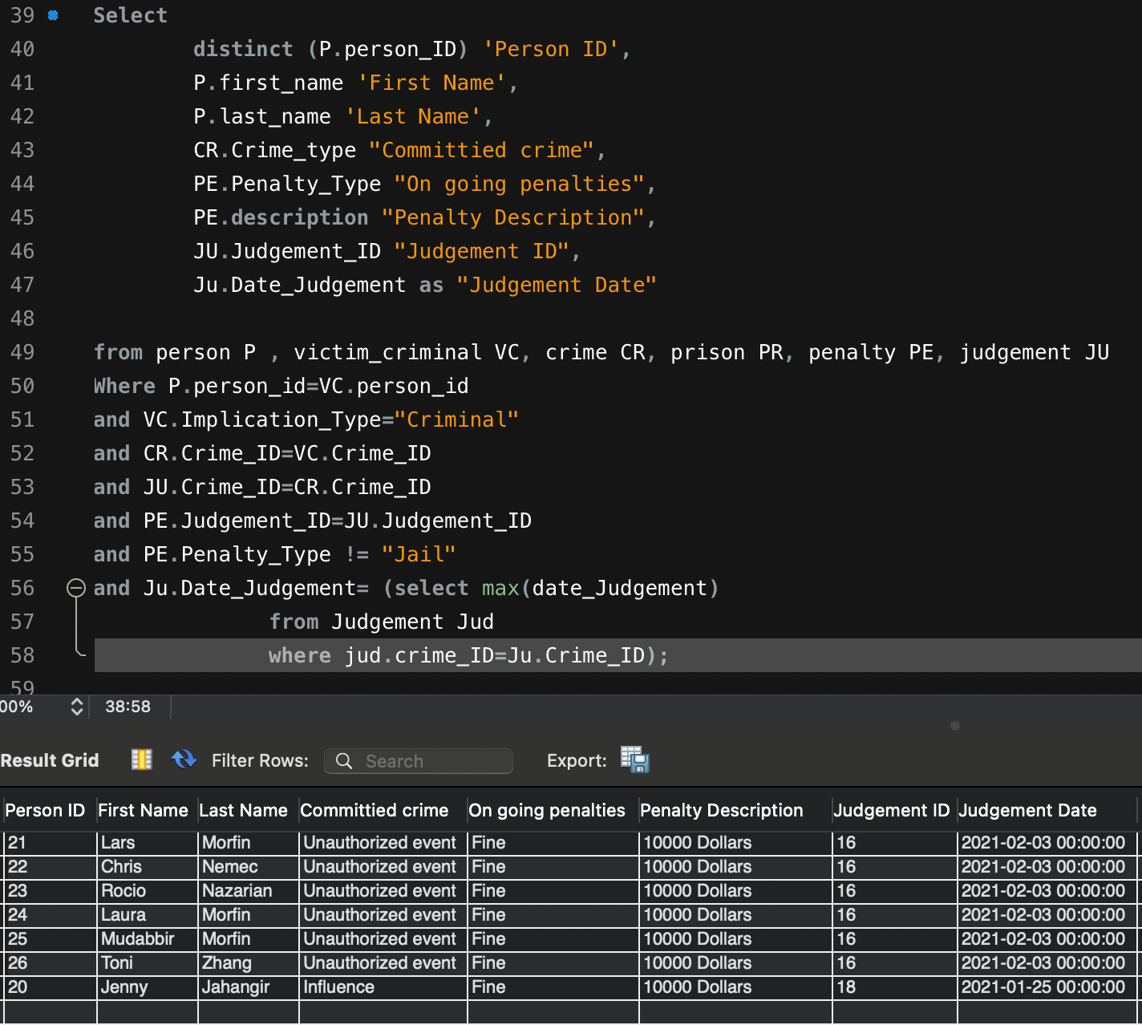

## List of Judgement type, penalty received, and the type of crime committed.

Code:

Select CR.Crime_ID,

CR.Crime_type,

JU.Decision,

JU.Court_type,

PE.Penalty_Type

From Crime as CR, Judgement as JU , Victim_Criminal as VC , penalty PE

where CR.crime_ID=JU.Crime_ID

and CR.Crime_ID = VC.Crime_ID

and PE.Judgement_ID = JU.Judgement_ID

and VC.Implication_Type = 'Criminal'

and Ju.Date= (select max(date)

from Judgement Jud

where jud.crime_ID=Ju.Crime_ID);

Results:

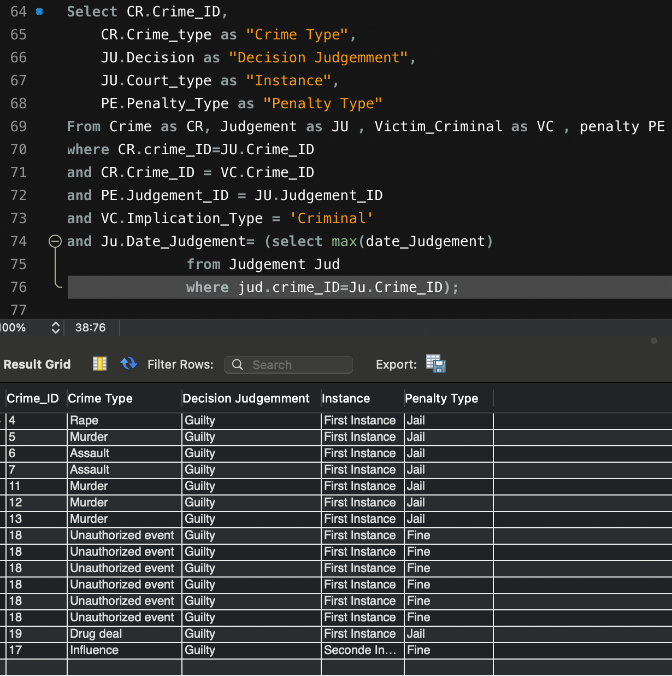

## List of prison with criminals, count of prisoners, maximum capacity, their occupancy rate and average age of prisoners

Code:

select

PR.Prison_ID,

PR.name ,

count(distinct(PER.Person_ID)) as "number of person" ,

max_capacity,

(count(distinct(PER.Person_ID))/ max_capacity) as "taux de remplissement",

AVG(TIMESTAMPDIFF(YEAR, PER.birth, CURDATE())) AS avg_age

from prison PR

join penalty PEN on PR.prison_ID = PEN.prison_ID

join judgement JU on JU.judgement_ID = PEN.judgement_ID

join crime CR on CR.Crime_id = JU.Crime_ID

join victim_criminal VC on VC.Crime_ID = CR.Crime_id

join person PER on PER.Person_ID= VC.Person_ID

where end_penalty > date(now())

and Implication_Type ='Criminal'

and Ju.Date= (select max(date)

from Judgement Jud

where jud.crime_ID=Ju.Crime_ID)

group by PR.Prison_ID;

Results:

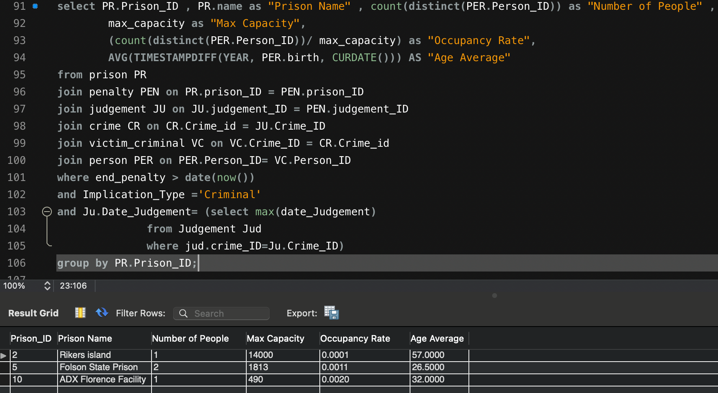

## List of case with “Unknown” Criminal cases, including the related crime details and evidences

Code:

select

distinct(CA.Case_ID) ,

CR.Crime_ID,

CA.Name ,

CR.Date_Crime,

CR.Crime_type , E.type , E.Description

from cases CA , crime CR , evidence E ,victim_criminal VC

where CA.Case_ID = CR.Case_ID

and CA.Case_ID= E.Case_ID

and VC.Crime_ID = CR.Crime_ID

and Person_ID is NULL

order by type , Date_Crime;

Results:

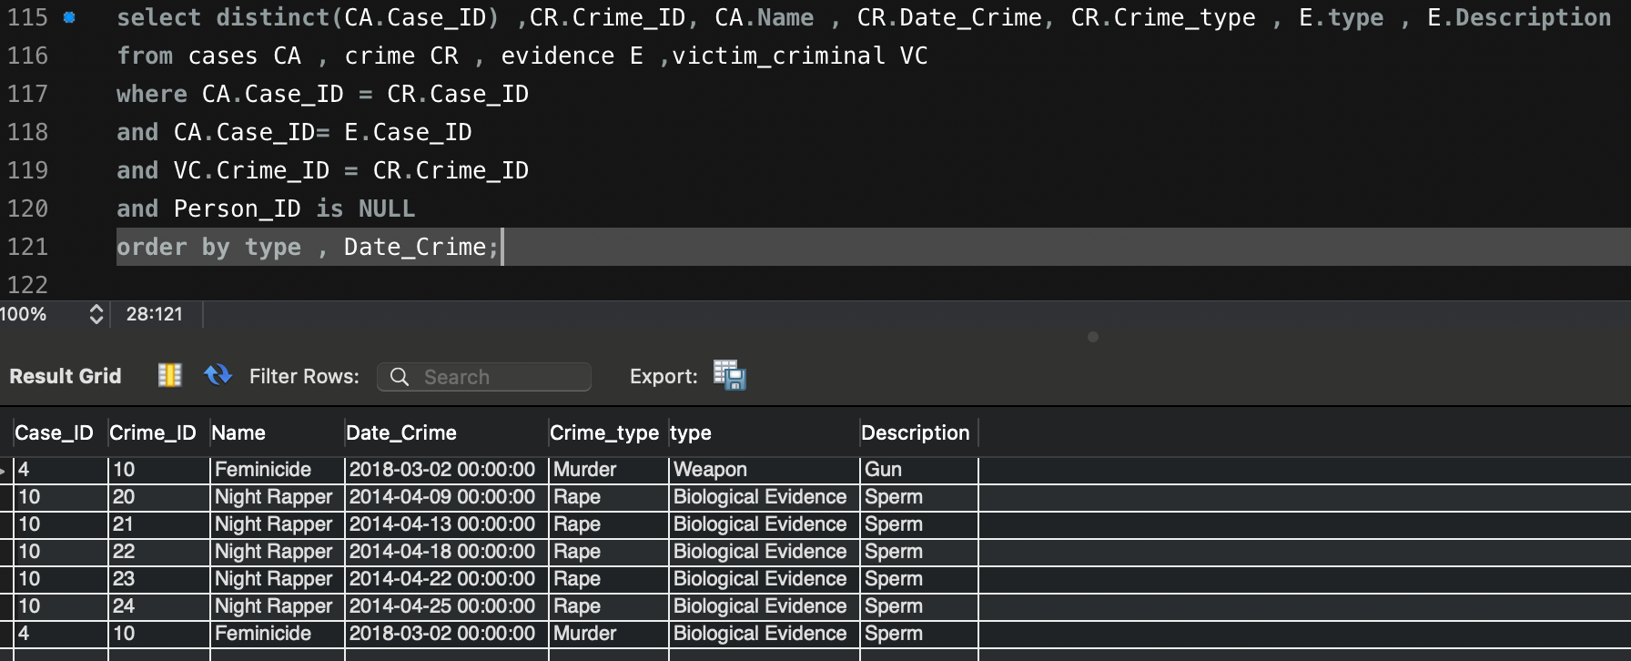

## Number of committed crimes per cases

Code:

select

CA.Case_ID ,

CA.Name ,

count(CR.Crime_type)

from cases CA , crime CR

where CA.Case_ID = CR.Case_ID

group by Case_ID;

Results:

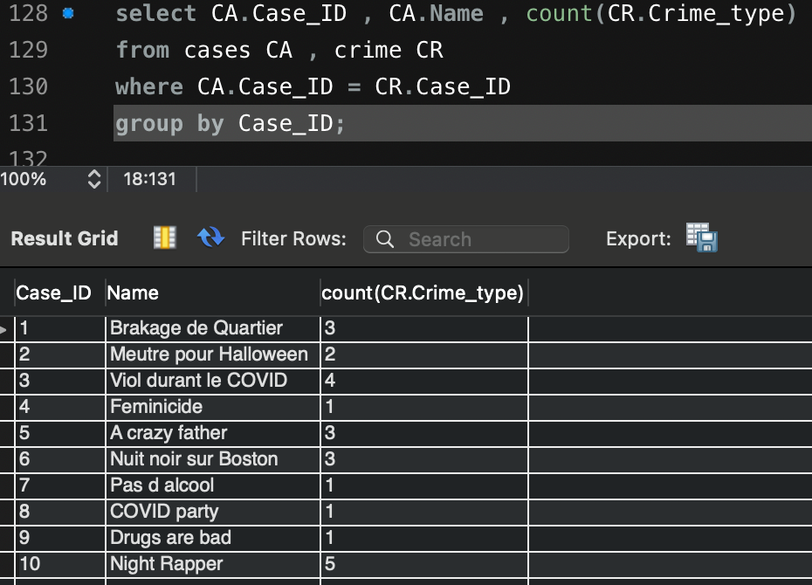

## Cases currently open and the number of related crimes and criminals

Code:

select

CA.Case_ID,

CA.Name ,

CA.Opening_Date ,

count(CR.Crime_type),

count(distinct(VC.Person_ID)) as "NBR OF kNOWN CRIMINALS"

from cases CA , crime CR , Victim_Criminal VC

where CA.Case_ID = CR.Case_ID

and VC.Crime_ID = CR.Crime_ID

and CA.Closing_Date is null

and VC.Implication_Type = 'Criminal'

group by CA.Case_ID;

Results:

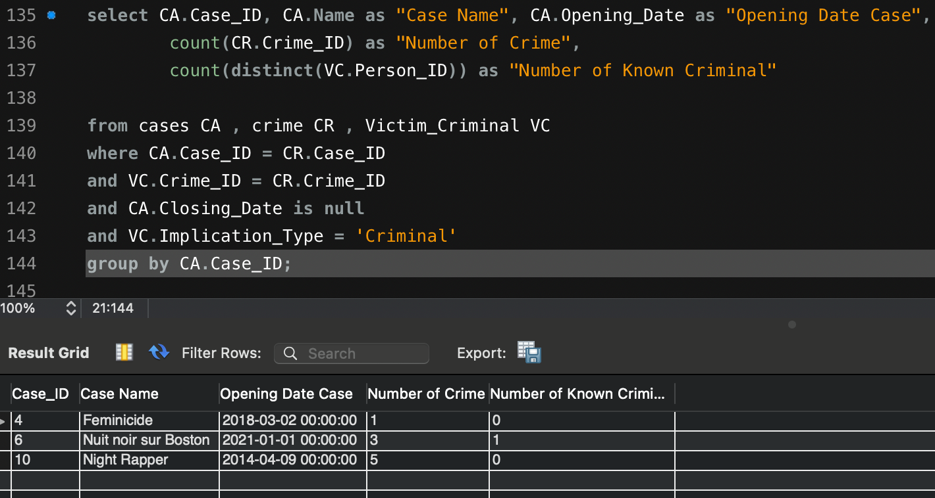

## List of Cases including their name and the related witness

Code:

select

CA.Case_ID ,

CA.Name ,

W.witness_ID ,

PER.First_Name ,

PER.Last_Name

from cases CA ,witness W,person PER

where W.Case_ID = CA.Case_ID

and PER.Person_ID = W.Person_ID;

Results:

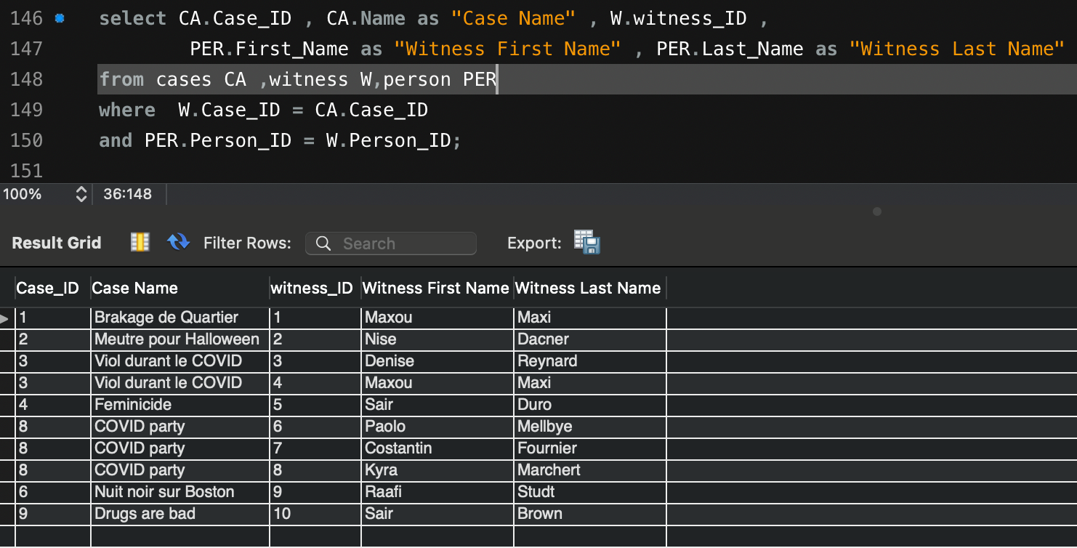

### Cases list with administrative information judge and officer name, instance, opening , closing case date and duration

Code:

select

CA.case_ID,

CA.Name ,

CR.Crime_ID,

JU.Judge ,

JU.Court_Type ,

Opening_Date as "Case date" ,

Date as "Judgement Date" ,

TIMESTAMPDIFF(YEAR, Opening_Date, Date) as “Case Duration”

from cases CA

left join crime CR on CA.Case_ID = CR.Case_ID

left join Judgement JU on JU.Crime_ID = CR.Crime_ID

and Ju.Date= (select max(date)

from Judgement Jud

where jud.crime_ID=Ju.Crime_ID);

Results:

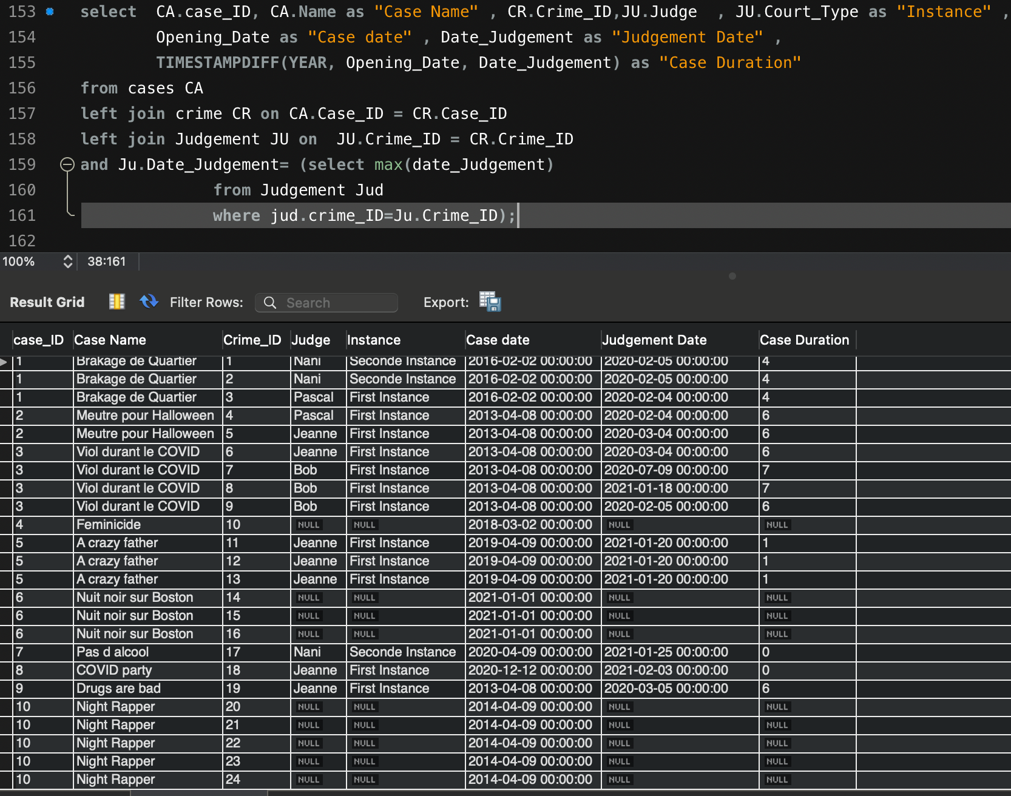

# Procedure

Based on the above ER model and queries we came up with the following procedures. Because of the nature of the sector, in addition to the two output procedures, we also included a procedure without output to provide criminal records for the Boston Police Department.

## With Output

### Person details and number of crimes for a specific person

This code shows the first name , last name , birth and the number of crimes committed by someone. To find those informations , the procedure need a PersonID as an Input. The outputs ( out_first_name , out_last_name ,out_birth) are renamed copies of existing columns but out_Count_Crime_ID is an output that takes the sum of crimes order by CrimeID

Code:

CREATE DEFINER=`root`@`localhost` PROCEDURE `Criminal_rec_out_prc`(

in in_Person_ID int,

out out_first_name varchar(45),

out out_last_name varchar(45),

out out_Birth datetime,

out out_Count_Crime_ID int)

**begin**

select

P.first_name 'First Name',

P.last_name 'Last Name',

p.Birth,

count(CR.Crime_ID) into out_first_name ,

out_last_name ,

out_Birth,

out_Count_Crime_ID

from person P

left join Victim_Criminal VC on VC.Person_ID = P.Person_ID

left join crime CR on Cr.Crime_ID = VC.Crime_ID

where P.Person_ID = in_Person_ID

group by P.Person_ID;

**END**

Call:

call Criminal_rec_out_prc(10,@out_first_name, @out_last_name ,@out_Birth, @out_Count_Crime_ID);

Select:

select @out_first_name as "First Name", @out_last_name as "Last Name" ,@out_Birth as "Birth",@out_Count_Crime_ID as "Number of Crimes" ;

Results:

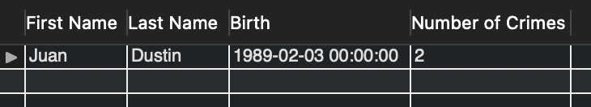

### Level of offense

This code will show CrimeID , Type of crime and a new column that will be the level of offence associated when the user calls the procedure with the CrimeID. The outputs ( out_Crime_ID and out_Crime_Type) are copies of existing columns. To obtain it, v_type has been created in to highlight the type of level of offence associated with type of crimes, they are three of them: Felonies, Misdemeanor, Infraction. When the information is stored in V_Store , we can then obtain the output that refers to it.

Code:

CREATE DEFINER=`root`@`localhost` PROCEDURE `Lvl_of_Offence_PRC`(

in in_Crime_ID int,

out out_Crime_ID int,

out level_of_offence varchar(155),

out out_Crime_type varchar(105))

**BEGIN**

DECLARE v_type varchar(10);

select Crime_ID,Crime_type ,Crime_type

into out_Crime_ID,v_type , out_Crime_type

from crime

where Crime_ID=in_Crime_ID;

If v_type = "Murder" or v_type = "Rape"

then set level_of_offence = "Felonies";

elseif v_type = "Theft" or v_type = "Drug deal" or v_type = "Assault"

then set level_of_offence = "Misdemeanor";

else

set level_of_offence = "Infraction";

end if;

END

Call:

call Lvl_of_Offence_PRC(4,@out_Crime_ID,@level_of_offence,@out_Crime_type);

Select:

select @out_Crime_ID as "Crime_ID",@out_Crime_type as "Crime Type",@level_of_offence as "level of Offence";

Results:

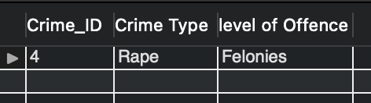

## Without Output

### Criminal Record

This procedure is one of the procedures that highlights the usefulness of our SQI as it gathers, using the first and last names, all the information related to each individual who is involved as a criminal in the database. We get information such as the personID , first name, last name, age, but also the crimes, judgement (first instance, second instance,...) and penalty associated to it. The condition (only criminal) was placed to avoid information redundancy and thus obtain only one line of code for each committed crime.

Code:

CREATE DEFINER=`root`@`localhost` PROCEDURE `criminal_rec_prc`(

in in_first_name VARCHAR(45),

in in_last_name VARCHAR(45))

begin

select

P.Person_ID ,

P.first_name 'First Name',

P.last_name 'Last Name',

p.Birth ,

CR.Crime_ID ,

CR.Crime_type,

JU.Court_Type,

JU.Decision ,

PEN.Penalty_Type

from person P

left join victim_criminal VC on P.person_id=VC.person_id

left join Crime CR on CR.Crime_ID=VC.Crime_ID

left join Judgement JU on JU.Crime_ID = CR.Crime_ID

left join Penalty PEN on PEN.Judgement_ID = JU.Judgement_ID

where first_name = in_first_name

and last_name = in_last_name

and VC.Implication_Type="Criminal";

END

Call:

call criminal_rec_prc ("May","Ancerd");

Result:

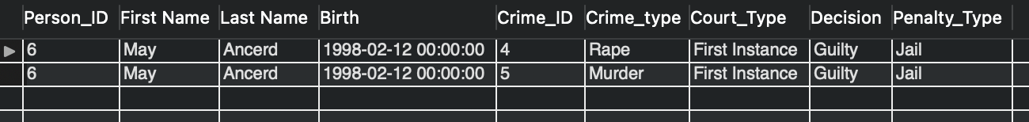

APPENDIX

# CREATE TABLES:

## Person

CREATE TABLE `person` (

`Person_ID` int NOT NULL,

`First_Name` varchar(45) NOT NULL,

`Last_Name` varchar(45) NOT NULL,

`Nationality` varchar(45) NOT NULL,

`Gender` varchar(45) NOT NULL,

`Adress` varchar(100) NOT NULL,

`Birth` datetime NOT NULL,

PRIMARY KEY (`Person_ID`)

) ENGINE=InnoDB DEFAULT CHARSET=utf8;

## Victim Criminal

CREATE TABLE `victim_criminal` (

`Implicated_ID` int NOT NULL,

`Implication_Type` enum('Victim','Criminal','Unknown') NOT NULL,

`Questionning` text,

`Status` enum('Dead','Alive','Missing','Unknown') NOT NULL,

`Crime_ID` int NOT NULL,

`Person_ID` int DEFAULT NULL,

PRIMARY KEY (`Implicated_ID`),

KEY `fk_Implicated_Person.1_idx` (`Person_ID`),

KEY `fk_Victim_Criminal_crime1_idx` (`Crime_ID`),

CONSTRAINT `fk_Implicated_Person.1` FOREIGN KEY (`Person_ID`) REFERENCES `person` (`Person_ID`),

CONSTRAINT `fk_Victim_Criminal_crime1` FOREIGN KEY (`Crime_ID`) REFERENCES `crime` (`Crime_ID`)

) ENGINE=InnoDB DEFAULT CHARSET=utf8;

## Crime

CREATE TABLE crime (

Crime_ID int NOT NULL,

Crime_type enum('Murder','Rape','Theft','Assault','Unauthorized event','Influence','Drug deal') NOT NULL,

Date_Crime datetime NOT NULL,

Case_ID int NOT NULL,

PRIMARY KEY (Crime_ID),

KEY fk_Crime._Cases.1_idx (Case_ID),

CONSTRAINT fk_Crime._Cases.1 FOREIGN KEY (Case_ID) REFERENCES Cases (Case_ID)

) ENGINE=InnoDB DEFAULT CHARSET=utf8;

## Witness

CREATE TABLE `witness` (

`Witness_ID` int NOT NULL,

`Questionning` text NOT NULL,

`Person_ID` int NOT NULL,

`Case_ID` int NOT NULL,

PRIMARY KEY (`Witness_ID`),

KEY `fk_Witness_Person.1_idx` (`Person_ID`),

KEY `fk_Witness_Cases.1_idx` (`Case_ID`),

CONSTRAINT `fk_Witness_Cases.1` FOREIGN KEY (`Case_ID`) REFERENCES `cases` (`Case_ID`),

CONSTRAINT `fk_Witness_Person.1` FOREIGN KEY (`Person_ID`) REFERENCES `person` (`Person_ID`)

) ENGINE=InnoDB DEFAULT CHARSET=utf8;

## Cases

CREATE TABLE `cases` (

`Case_ID` int NOT NULL,

`Name` varchar(45) NOT NULL,

`Officer` varchar(45) NOT NULL,

`Opening_Date` datetime NOT NULL,

`Closing_Date` datetime DEFAULT NULL,

PRIMARY KEY (`Case_ID`)

) ENGINE=InnoDB DEFAULT CHARSET=utf8;

## Evidence

CREATE TABLE `evidence` (

`Evidence_ID` int NOT NULL,

`type` enum('Weapon','Biological Evidence','Prints','Drug') NOT NULL,

`Collected_Date` datetime NOT NULL,

`Description` varchar(45) NOT NULL,

`Case_ID` int NOT NULL,

PRIMARY KEY (`Evidence_ID`),

KEY `fk_Evidence._Cases.1_idx` (`Case_ID`),

CONSTRAINT `fk_Evidence._Cases.1` FOREIGN KEY (`Case_ID`) REFERENCES `cases` (`Case_ID`)

) ENGINE=InnoDB DEFAULT CHARSET=utf8;

## Judgement

CREATE TABLE `judgement` (

`Judgement_ID` int NOT NULL,

`Court_Type` enum('First Instance','Seconde Instance') NOT NULL,

`Judge` varchar(45) NOT NULL,

`Decision` enum('Guilty','Not Guilty') NOT NULL,

`Date_Judgement` datetime NOT NULL,

`Crime_ID` int NOT NULL,

PRIMARY KEY (`Judgement_ID`),

KEY `fk_Judgement_crime1_idx` (`Crime_ID`),

CONSTRAINT `fk_Judgement_crime1` FOREIGN KEY (`Crime_ID`) REFERENCES `crime` (`Crime_ID`)

) ENGINE=InnoDB DEFAULT CHARSET=utf8;

## Penalty

CREATE TABLE `penalty` (

`Penalty_ID` int NOT NULL,

`Penalty_Type` enum('Jail','Fine') NOT NULL,

`Description` varchar(255) NOT NULL,

`End_Penalty` datetime DEFAULT NULL,

`Prison_ID` int DEFAULT NULL,

`Judgement_ID` int DEFAULT NULL,

PRIMARY KEY (`Penalty_ID`),

KEY `fk_Penalty_Prison.1_idx` (`Prison_ID`),

KEY `fk_Penalty_Judgement.1_idx` (`Judgement_ID`),

CONSTRAINT `fk_Penalty_Judgement.1` FOREIGN KEY (`Judgement_ID`) REFERENCES `judgement` (`Judgement_ID`),

CONSTRAINT `fk_Penalty_Prison.1` FOREIGN KEY (`Prison_ID`) REFERENCES `prison` (`Prison_ID`)

) ENGINE=InnoDB DEFAULT CHARSET=utf8;

## Prison

CREATE TABLE `prison` (

`Prison_ID` int NOT NULL,

`name` varchar(45) NOT NULL,

`State` varchar(45) NOT NULL,

`Max_Capacity` int NOT NULL,

PRIMARY KEY (`Prison_ID`)

) ENGINE=InnoDB DEFAULT CHARSET=utf8;

# Insert Tables

## Person

INSERT INTO Person VALUES

(1,'Lol','Cerdan','FR','F','777 Brockton Avenue, Abington MA 2351','1996-04-23 00:00:00'),

(2,'Ines','Nadrec','AN','F','30 Memorial Drive, Avon MA 2322','1986-05-14 00:00:00'),

(3,'Seni','Ernac','ES','M','250 Hartford Avenue, Bellingham MA 2019','1998-03-02 00:00:00'),

(4,'Nise','Dacner','GE','M','700 Oak Street, Brockton MA 2301','1996-04-03 00:00:00'),

(5,'June','Racned','UK','F','66-4 Parkhurst Rd, Chelmsford MA 1824','1956-03-14 00:00:00'),

(6,'May','Ancerd','USA','M','591 Memorial Dr, Chicopee MA 1020','1998-02-12 00:00:00'),

(7,'Maxou','Maxi','SW','M','55 Brooksby Village Way, Danvers MA 1923','1996-02-28 00:00:00'),

(8,'Jeanne','Dutrieux','PO','F','137 Teaticket Hwy, East Falmouth MA 2536','1946-05-14 00:00:00'),

(9,'Paul','David','BE','M','42 Fairhaven Commons Way, Fairhaven MA 2719','1978-03-11 00:00:00'),

(10,'Juan','Dustin','IT','M','374 William S Canning Blvd, Fall River MA 2721','1989-02-03 00:00:00'),

(11,'Denise','Reynard','USA','F','121 Worcester Rd, Framingham MA 1701','1974-03-04 00:00:00'),

(12,'Pascal','Pearson','FR','M','677 Timpany Blvd, Gardner MA 1440','1988-12-03 00:00:00'),

(13,'Christian ','Durein ','MA','M','337 Russell St, Hadley MA 1035','1945-02-27 00:00:00'),

(14,'Evelyne','Fournier','FR','F','295 Plymouth Street, Halifax MA 2338','1970-02-05 00:00:00'),

(15,'Bob','Marchert','USA','M','1775 Washington St, Hanover MA 2339','1983-03-04 00:00:00'),

(16,'Caroll','Studt','JN','F','280 Washington Street, Hudson MA 1749','1969-03-21 00:00:00'),

(17,'Cristian','Brown','CH','M','20 Soojian Dr, Leicester MA 1524','1989-04-23 00:00:00'),

(18,'Laurin','Pant','AN','F','11 Jungle Road, Leominster MA 1453','1999-03-02 00:00:00'),

(19,'Yse','Aiello','ES','F','301 Massachusetts Ave, Lunenburg MA 1462','1997-04-03 00:00:00'),

(20,'Jenny','Jahangir','GE','F','780 Lynnway, Lynn MA 1905','1955-03-14 00:00:00'),

(21,'Lars','Morfin','UK','M','70 Pleasant Valley Street, Methuen MA 1844','1999-02-12 00:00:00'),

(22,'Chris','Nemec','USA','M','830 Curran Memorial Hwy, North Adams MA 1247','1990-02-28 00:00:00'),

(23,'Rocio','Nazarian','SW','F','1470 S Washington St, North Attleboro MA 2760','1935-05-14 00:00:00'),

(24,'Laura','Morfin','PO','F','506 State Road, North Dartmouth MA 2747','1989-03-11 00:00:00'),

(25,'Mudabbir','Morfin','BE','M','742 Main Street, North Oxford MA 1537','1961-02-03 00:00:00'),

(26,'Toni','Zhang','IT','M','72 Main St, North Reading MA 1864','1978-03-04 00:00:00'),

(27,'Fredrik','Nemec','USA','M','200 Otis Street, Northborough MA 1532','1963-12-03 00:00:00'),

(28,'Hannah','Pant','FR','F','180 North King Street, Northhampton MA 1060','1978-03-11 00:00:00'),

(29,'Khaja','Wang','MA','M','555 East Main St, Orange MA 1364','1989-02-03 00:00:00'),

(30,'Julia','Kromer','FR','F','555 Hubbard Ave-Suite 12, Pittsfield MA 1201','1974-03-04 00:00:00'),

(31,'Valentina','Chabanel','USA','F','300 Colony Place, Plymouth MA 2360','1988-12-03 00:00:00'),

(32,'Sebastian','Chabanel','USA','M','301 Falls Blvd, Quincy MA 2169','1945-02-27 00:00:00'),

(33,'Frida','Chabanel','USA','F','36 Paramount Drive, Raynham MA 2767','1970-02-05 00:00:00'),

(34,'Costanza','Chabanel','USA','F','450 Highland Ave, Salem MA 1970','1983-03-04 00:00:00'),

(35,'Costantin','Lopez','ES','M','1180 Fall River Avenue, Seekonk MA 2771','1969-03-21 00:00:00'),

(36,'Kyra','Resag','GE','F','1105 Boston Road, Springfield MA 1119','1989-04-23 00:00:00'),

(37,'Raafi','Khawaja','SW','M','100 Charlton Road, Sturbridge MA 1566','1999-03-02 00:00:00'),

(38,'Sair','Duro','PO','M','262 Swansea Mall Dr, Swansea MA 2777','1997-04-03 00:00:00'),

(39,'Paolo','Mellbye','BE','M','36 Paramount Drive, Raynham MA 2767','1955-03-14 00:00:00'),

(40,'Costantin','Fournier','USA','M','550 Providence Hwy, Walpole MA 2081','1997-04-03 00:00:00'),

(41,'Kyra','Marchert','ES','F','352 Palmer Road, Ware MA 1082','1955-03-14 00:00:00'),

(42,'Raafi','Studt','GE','M','3005 Cranberry Hwy Rt 6 28, Wareham MA 2538','1999-02-12 00:00:00'),

(43,'Sair','Brown','SW','M','250 Rt 59, Airmont NY 10901','1990-02-28 00:00:00'),

(44,'Paolo','Pant','PO','M','141 Washington Ave Extension, Albany NY 12205','1990-03-01 00:00:00');

## Victim Criminal

INSERT INTO Criminal_Victim_final VALUES

(1,'Criminal',NULL,'Alive',1,'9'),

(2,'Criminal',NULL,'Alive',2,'9'),

(3,'Criminal',NULL,'Alive',3,'1'),

(4,'Victim',NULL,'Dead',1,'2'),

(5,'Victim',NULL,'Dead',2,'2'),

(6,'Victim',NULL,'Dead',3,'2'),

(7,'Criminal',NULL,'Alive',4,'6'),

(8,'Criminal',NULL,'Alive',5,'6'),

(9,'Victim',NULL,'Dead',4,'3'),

(10,'Victim',NULL,'Dead',5,'3'),

(11,'Criminal',NULL,'Alive',6,'10'),

(12,'Criminal',NULL,'Alive',7,'10'),

(13,'Criminal',NULL,'Alive',8,'13'),

(14,'Criminal',NULL,'Alive',9,'13'),

(15,'Victim',NULL,'Alive',6,'14'),

(16,'Victim',NULL,'Alive',7,'14'),

(17,'Victim',NULL,'Alive',8,'17'),

(18,'Victim',NULL,'Alive',9,'17'),

(19,'Victim',NULL,'Dead',10,'37'),

(20,'Criminal',NULL,'Dead',11,'31'),

(21,'Criminal',NULL,'Dead',12,'31'),

(22,'Criminal',NULL,'Dead',13,'31'),

(23,'Victim',NULL,'Dead',11,'32'),

(24,'Victim',NULL,'Dead',12,'33'),

(25,'Victim',NULL,'Dead',13,'34'),

(26,'Criminal',NULL,'Alive',14,'18'),

(27,'Criminal',NULL,'Alive',15,'18'),

(28,'Criminal',NULL,'Alive',16,'18'),

(29,'Victim',NULL,'Dead',14,'19'),

(30,'Victim',NULL,'Dead',15,'19'),

(31,'Victim',NULL,'Dead',16,'19'),

(32,'Criminal',NULL,'Alive',17,'20'),

(33,'Criminal',NULL,'Alive',18,'21'),

(34,'Criminal',NULL,'Alive',18,'22'),

(35,'Criminal',NULL,'Alive',18,'23'),

(36,'Criminal',NULL,'Alive',18,'24'),

(37,'Criminal',NULL,'Alive',18,'25'),

(38,'Criminal',NULL,'Alive',18,'26'),

(39,'Criminal',NULL,'Alive',19,'27'),

(40,'Victim',NULL,'Alive',20,'28'),

(41,'Victim',NULL,'Alive',21,'29'),

(42,'Victim',NULL,'Alive',22,'30'),

(43,'Victim',NULL,'Alive',23,'35'),

(44,'Victim',NULL,'Alive',24,'36'),

(45,'Criminal',NULL,'Unknown',20,'Null'),

(46,'Criminal',NULL,'Unknown',21,'Null'),

(47,'Criminal',NULL,'Unknown',22,'Null'),

(48,'Criminal',NULL,'Unknown',23,'Null'),

(49,'Criminal',NULL,'Unknown',24,'Null'),

(50,'Criminal',NULL,'Unknown',10,'Null');

## Crime

INSERT INTO crime VALUES

(1,'Murder','2016-01-31 00:00:00',1),

(2,'Theft','2016-01-31 00:00:00',1),

(3,'Theft','2016-01-31 00:00:00',1),

(4,'Rape','2013-04-08 00:00:00',2),

(5,'Murder','2013-04-08 00:00:00',2),

(6,'Assault','2013-04-08 00:00:00',3),

(7,'Assault','2013-04-08 00:00:00',3),

(8,'Assault','2013-04-08 00:00:00',3),

(9,'Assault','2013-04-08 00:00:00',3),

(10,'Murder','2018-03-02 00:00:00',4),

(11,'Murder','2019-03-09 00:00:00',5),

(12,'Murder','2019-03-09 00:00:00',5),

(13,'Murder','2019-03-09 00:00:00',5),

(14,'Murder','2021-01-01 00:00:00',6),

(15,'Theft','2021-01-01 00:00:00',6),

(16,'Rape','2021-01-01 00:00:00',6),

(17,'Influence','2020-04-09 00:00:00',7),

(18,'Unauthorized event','2020-12-12 00:00:00',8),

(19,'Drug deal','2013-04-08 00:00:00',9),

(20,'Rape','2014-04-09 00:00:00',10),

(21,'Rape','2014-04-13 00:00:00',10),

(22,'Rape','2014-04-18 00:00:00',10),

(23,'Rape','2014-04-22 00:00:00',10),

(24,'Rape','2014-04-25 00:00:00',10);

## Cases

INSERT INTO Case VALUES

(1,'Brakage de Quartier','Denise','2016-02-02 00:00:00','2020-02-05'),

(2,'Meutre pour Halloween','Paul','2013-04-08 00:00:00','2021-01-16'),

(3,'Viol durant le COVID','Carroll','2013-04-08 00:00:00','2021-01-16'),

(4,'Feminicide','Carroll','2018-03-02 00:00:00','NULL'),

(5,'A crazy father','Denise','2019-04-09 00:00:00','2021-01-15'),

(6,'Nuit noir sur Boston','Denise','2021-01-01 00:00:00','NULL'),

(7,'Pas d alcool','Paul','2020-04-09 00:00:00','2020-05-10'),

(8,'COVID party','Denise','2020-12-12 00:00:00','2021-12-12'),

(9,'Drugs are bad','Paul','2013-04-08 00:00:00','2020-02-05'),

(10,'Night Rapper','Denise','2014-04-09 00:00:00','NULL');

## Witness

INSERT INTO Witness VALUES

(1,7,1,'slt'),

(2,4,2,'tg'),

(3,11,3,'slt ftg'),

(4,7,3,'ouesh je me suis perdu'),

(5,38,4,'bla'),

(6,39,8,'bruit'),

(7,40,8,'buot'),

(8,41,8,'buits'),

(9,42,6,'bri'),

(10,43,9,'blon');

## Evidence

INSERT INTO Evidences VALUES

(1,'Weapon','2020-02-02 00:00:00','Gun',1),

(2,'Weapon','2019-04-03 00:00:00','Knife',2),

(3,'Biological Evidence','2020-03-04 00:00:00','Sperm',3),

(4,'Weapon','2018-03-03 00:00:00','Gun',4),

(5,'Biological Evidence','2018-03-03 00:00:00','Sperm',4),

(6,'Weapon','2019-09-04 00:00:00','Gun',5),

(7,'Biological Evidence','2021-02-01 00:00:00','Sperm',6),

(8,'Drug','2013-04-09 00:00:00','Canabis',9),

(9,'Drug','2013-04-09 00:00:00','Cocaine',9),

(10,'Biological Evidence','2014-09-06 00:00:00','Sperm',10);

## Judgement

INSERT INTO judgement VALUES

(1,'First Instance','Pascal','Guilty','2020-02-04 00:00:00',1),

(2,'Seconde Instance','Nani','Not Guilty','2020-02-05 00:00:00',1),

(3,'First Instance','Pascal','Guilty','2020-02-04 00:00:00',2),

(4,'Seconde Instance','Nani','Not Guilty','2020-02-05 00:00:00',2),

(5,'First Instance','Pascal','Not Guilty','2020-02-04 00:00:00',3),

(6,'First Instance','Pascal','Guilty','2020-02-04 00:00:00',4),

(7,'First Instance','Jeanne','Guilty','2020-03-04 00:00:00',5),

(8,'First Instance','Jeanne','Guilty','2020-03-04 00:00:00',6),

(9,'First Instance','Bob','Guilty','2020-07-09 00:00:00',7),

(10,'First Instance','Bob','Not Guilty','2021-01-18 00:00:00',8),

(11,'First Instance','Bob','Not Guilty','2020-02-05 00:00:00',9),

(12,'First Instance','Jeanne','Guilty','2021-01-20 00:00:00',11),

(13,'First Instance','Jeanne','Guilty','2021-01-20 00:00:00',12),

(14,'First Instance','Jeanne','Guilty','2021-01-20 00:00:00',13),

(15,'First Instance','Jeanne','Guilty','2020-10-09 00:00:00',17),

(16,'First Instance','Jeanne','Guilty','2021-02-03 00:00:00',18),

(17,'First Instance','Jeanne','Guilty','2020-03-05 00:00:00',19),

(18,'Seconde Instance','Nani','Guilty','2021-01-25 00:00:00',17);

## Penalty

INSERT INTO penalty VALUES

(1,'Jail','10 Years','2030-02-04','1',1),

(2,'Jail','10 Years','2030-02-04','1',3),

(3,'Jail','20 Years','2030-02-04','5',6),

(4,'Jail','20 Years','2030-02-04','5',7),

(5,'Jail','20 Years','2030-02-04','5',8),

(6,'Jail','20 Years','2030-02-04','5',9),

(7,'Jail','99 years','2120-01-20','10',12),

(8,'Jail','99 years','2120-01-20','10',13),

(9,'Jail','99 years','2120-01-20','10',14),

(10,'Jail','6 months','2021-10-03','2',15),

(11,'Fine','10000 Dollars','NULL','NULL',16),

(12,'Jail','20 Years','2040-03-05','2',17),

(13,'Fine','10000 Dollars','NULL','NULL',18);

## Prison

INSERT INTO Prison VALUES

(1,'US Penitentiary Marion','Illinois',1000),

(2,'Rikers island','New York',14000),

(3,'Louisiana State Penitentiary','Louisiana',5000),

(4,'Leavenworth Federal Penitentiary','Kansas',2000),

(5,'Folson State Prison','California',1813),

(6,'Attica Correctional Facility','New York',2150),

(7,'US Penitentiary Atlanta','Georgia',2000),

(8,'Sing Sing','New York',1700),

(9,'San Quentin State Prison','California',3302),

(10,'ADX Florence Facility','Colorado',490);